**Question 3**

Queries using aggregate functions (COUNT, AVG, MIN, MAX, SUM), Group by, Orderby.

Employee (E_id, E_name, Age, Salary)

1. Create Employee table containing all Records E_id, E_name, Age, Salary.

2. Count number of employee names from employee table

3. Find the Maximum age from employee table.

4. Find the Minimum age from employee table.

5. Find salaries of employee in Ascending Order.

6. Find grouped salaries of employees.

**Solution:**

**1. Creating the Employee Table**

CREATE TABLE Employee (

E_id INT PRIMARY KEY,

E_name VARCHAR (255),

Age INT,

Salary DECIMAL (10, 2)

);

DESC Employee;

O/P:

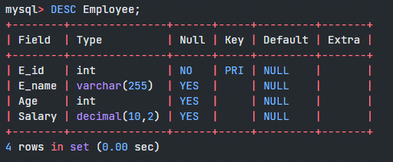

**2. Insert 6 Records into the Employee Table**

INSERT INTO Employee (E_id, E_name, Age, Salary)

VALUES

(1, 'Samarth', 30, 50000.00),

(2, 'Ramesh Kumar', 25, 50000.00),

(3, 'Seema Banu', 35, 60000.00),

(4, 'Dennis Anil', 28, 58000.00),

(5, 'Rehman Khan', 32, 58000.00),

(6, 'Pavan Gowda', 40, 70000.00);

SELECT * from Employee;

**O/P:**

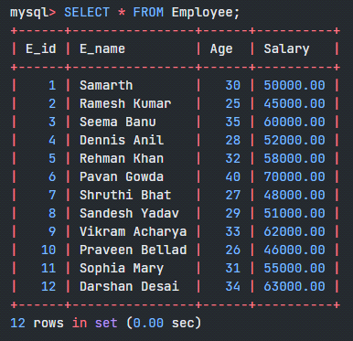

**3. Count Number of Employee Names**

SELECT COUNT(E_name) AS TotalEmployees

FROM Employee;

O/P:

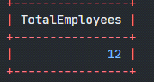

**4. Find the Maximum Age**

SELECT MAX(Age) AS MaxAge

FROM Employee;

O/P:

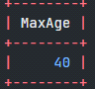

**5. Find the Minimum Age**

SELECT MIN(Age) AS MinAge

FROM Employee;

O/P:

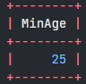

**6. Find Salaries of Employees in Ascending Order**

SELECT E_name, Salary

FROM Employee

ORDER BY Salary ASC; //Also replace ASC by DESC for descending order

O/P:

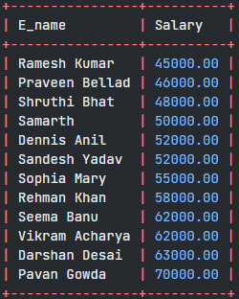

**7. Find Grouped Salaries of Employees**

SELECT Salary, COUNT(*) AS EmployeeCount

FROM Employee

GROUP BY Salary;

O/P:

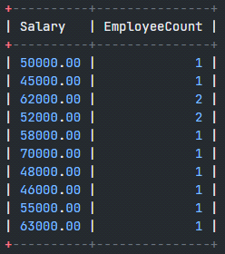

In these queries:

* **COUNT(E_name)** counts the number of non-NULL values in the **E_name** column.
* **MAX(Age)** finds the maximum age among the employees.
* **MIN(Age)** finds the minimum age among the employees.
* **ORDER BY Salary ASC** sorts the employees based on their salaries in ascending order.
* **GROUP BY Salary** groups employees by their salaries and counts the number of employees for each salary.